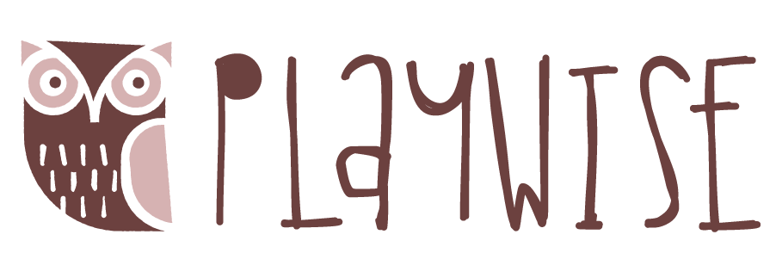
For Unique Children Company Registration Number: 11475647

Membership Services Application Form:
PARENT/CARER’S INFORMATION:
PARENT/ CARER NAME: | Click here to enter text.
HOME ADDRESS  & POSTCODE: | Click here to enter text.
DIRECT TELEPHONE: | Click here to enter text. |  |  | MOBILE: |  |  | Click here to enter text.
EMAIL:
CHILD’S INFORMATION
CHILD’S NAME | Click here to enter text.
GENDER | Please Select
DATE OF BIRTH | Click here to enter text.
CURRENT AGE | Choose an item. |  | Years |  | Choose an item. |  |  | Months
PRIME AREA OF NEED/ DIAGNOSIS | Click here to enter text.
GENERAL INFORMATION
Payment details- Payment must be made monthly in advance by standing order/ BACS to:
PlayWise Learning CIC Account Number: 65857997 Sort Code: 08-92-99
Please add your child’s name on your payment for reference
Please tick this box to confirm you have set up a standing order ☐
Please confirm the start date you have set up for payment to PlayWise CIC Click here to enter a date.
First applicable date is 1st April 2019
NB:
- Payment for membership services is for a minimum of 6 months
- Payment is to be paid monthly in advance
- Membership services will not commence until payment is made. This document forms part of your agreement to PlayWise Learning CIC
- Termination of Membership services is subject to 30 day’s notice in writing
PRINT NAME |  | SIGNATURE |  |  |  | DATE
sdfsdsdfsd |  | Click here to enter text. |  |  |  | Click here to enter a date.
Please submit this form via email to: info@playwise.org.uk
OR post to: PlayWise Hub, Sutton Central Library, St. Nicholas Way, Sutton, SM1 1EA
Contact us for further information on: 07736 338707
We will contact you upon receipt of this Request for Support.

For office use only: allocated membership number: Start date:

